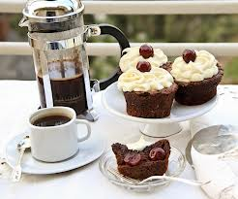Food and Drink

- Barney’s Burger Bar
- Cup Cakes & Coffee
- Juiced up
- toilets with disabled facilities

Activities / Attractions

- Country kitchen – all ages welcome
- Archery for ages 8 & above
- Hit the bell for ages 8 & above
- 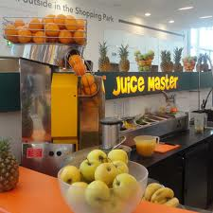Coconut Shy for ages 8 & above
- Hook a Duck for ages 2 - 6
- bouncy castle for ages 2 - 6

Saturday 12th June 2013

10.00am till 4.00pm

All welcome
Please support your local community

