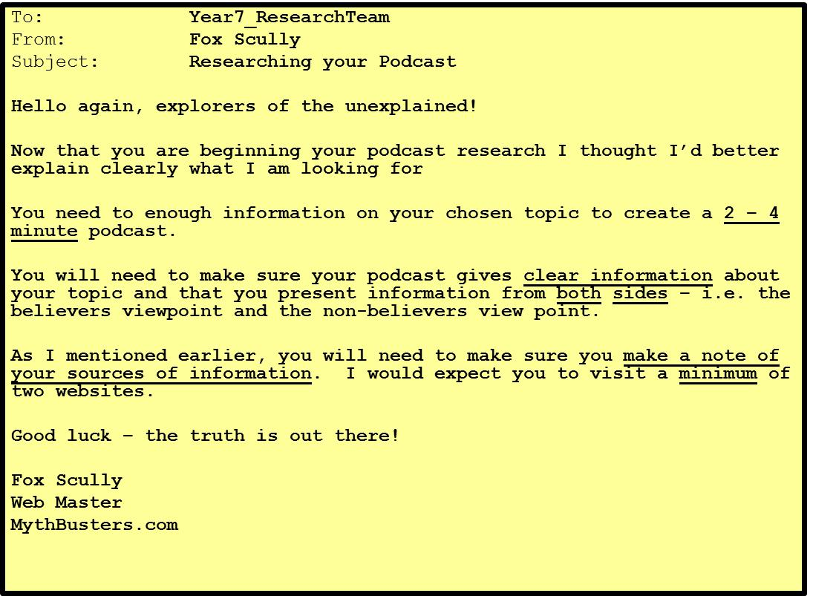
LESSON THREE/ACTIVITY ONE:
PODCAST RESEARCH

- Read the email from Fox Scully (above)

- Note how long the Podcast has to be and that you have research your topic from both viewpoints [i.e. for the Loch Ness Monster: you would research the view that it exists AND the view that it doesn’t)

- Research your Podcast using the techniques you have used in the previous two lessons
- Go to year 7 - term 2 MythBusters Lesson 3
- Load the Word document Podcast Research
- Add your name and the subject for your research by double clicking the text at the top
- Save the document in your network area
- Copy and paste your research and the links that you use into this document

