The hard disk

The hard disk is the main storage device in your computer.

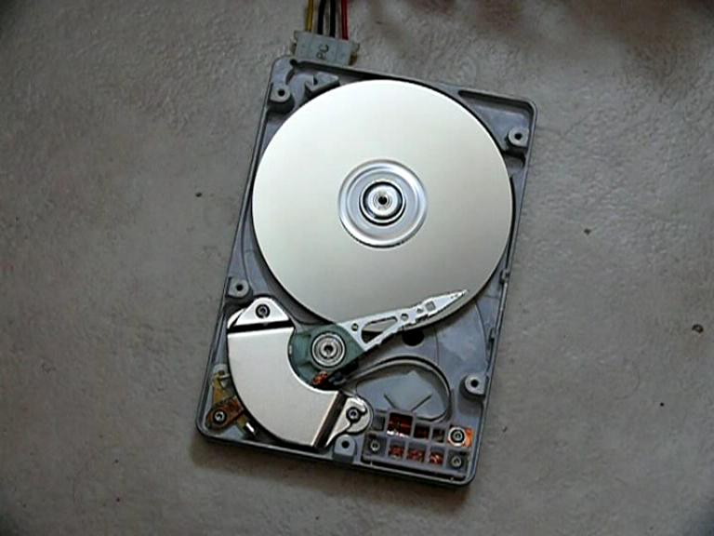
It is a bit like a filing cabinet: all of your data files and applications software are stored on it.

The hard disk contains a number of metal disks which have been coated with a special magnetic material.

The data is stored in this magnetic material.

The hard disk is known as a magnetic storage device.

In order to access the data, the platters spin many thousands of times a second and a magnetic read and write head floats just above the surface of the platter.

Hard disks are measured in Gigabytes. A typical hard disk size will be around 120 Gb - 1 Terabyte.

The CPU

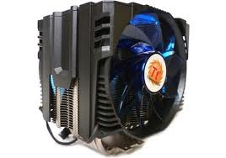
The brain of a computer is the CPU or Central Processing Unit.

Like a brain, it controls information and tells other parts what to do.

The type of CPU in a computer also determines how fast that computer can operate.

A CPU generates lots of heat, so there is usually a small fan nearby to cool it down.

The Motherboard
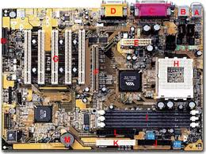
The motherboard is the main circuit board of your computer and is also known as the mainboard or logic board.
If you ever open your computer, the biggest piece you see is the motherboard.
Attached to the motherboard, you'll find the CPU, ROM, memory RAM expansion slots, PCI slots, and USB ports.
It also includes controllers for devices like the hard drive, DVD drive, keyboard, and mouse. Basically, the motherboard is what makes everything in your computer work together.

The power supply
A power supply gives electricity to a computer.
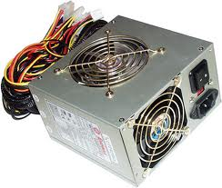
It receives power from an electrical outlet (wall plug) and converts the current from AC (alternating current) to DC (direct current), which is what the computer needs.
It also makes sure not too much or too little power is sent to the computer so it runs smoothly without overheating.
Of course, you should never have to remove the power supply, so it's best to leave it in the case.
While most computers have internal power supplies, many electronic devices use external ones. For example, some monitors and external hard drives have power supplies that are outside the main unit.
Since the power supply is the first place an electronic device receives electricity, it is also the most vulnerable to power surges and spikes. Therefore, power supplies are designed to handle changes in electrical current and still provide a regulated or consistent power output. Some include fuses that will blow if the surge is too great, protecting the rest of the equipment.

RAM
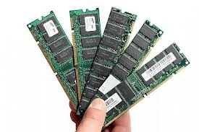
Stands for "Random Access Memory,"
RAM is made up of small memory chips. These are installed in slots on the motherboard of your computer.
Every time you open a program, it gets loaded from the hard drive into the RAM. This is because reading data from the RAM is much faster than reading data from the hard drive.
Running programs from the RAM of the computer allows them to function without any slow time.
The more RAM your computer has, the more data can be loaded from the hard drive into the RAM, which can effectively speed up your computer. In fact, adding RAM can be more beneficial to your computer's performance than upgrading the CPU.

