

INTRODUCTION TO HTML
Web Development for MID and Higher
This HTML Beginner Tutorial provides step by step instructions to creating simple HTML pages for beginners. The Tutorial assumes that you have absolutely no previous knowledge of HTML.

All the HTML code use on this tutorial has been previously tested and they all work

Lesson 1

Exercise 1: Creating Folder
Create folder in Half Term 2 and name it My Website

Exercise 2: Web Page Layout

Click on Start > All Programs > Accessories > open Notepad and enter the following

<HTML>

<HEAD>
</HEAD>

<BODY>
</BODY>

</HTML>

Click on File > Save As, navigate to the My Website folder you created, name it First WebPage.htm and click on Save.

Note: It is important to add the htm file extension after the file name to make the file become a web page.

Click on Start > Computer > navigate to My Website folder, notice that the file is showing as a web browser file type. To view it, double click on the file and the following web page will be display.

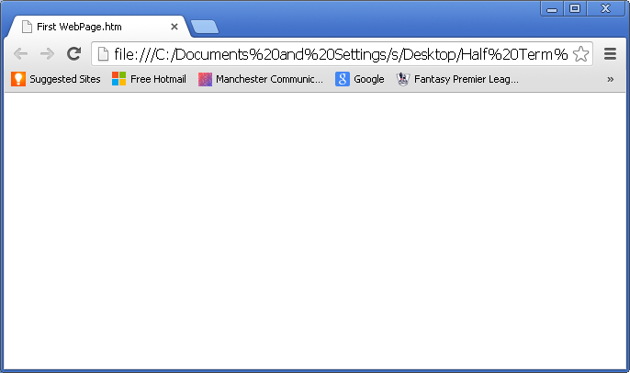
Exercise 3: Adding Text
To edit the web page, select the web page by clicking on it.
Click on Open dropdown menu > select Notepad as show below

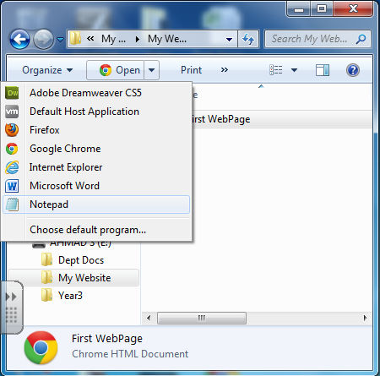

The following document would be display

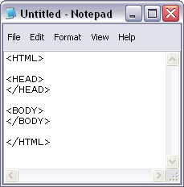

Add a header text and body text as shown below in bold on the Notepad document.

<HTML>

<HEAD>
<TITLE> My First Web Page </TITLE>
</HEAD>

<BODY>
This is my first web page
</BODY>

</HTML>

Click on File – Save.
Switch to the web browser and refresh the page by pressing on F5. Your page should be display as follow
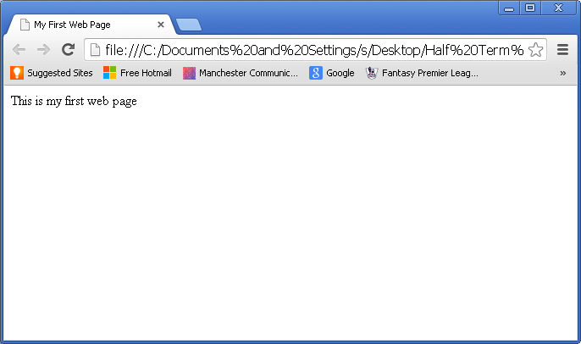
Notice the header
Notice the body

Exercise 4: Paragraph
It is important to realise that to split your text into paragraphs when it is displayed you must either use the paragraph tag <P> or the line break tag <BR>.

Open a new notepad and type in the following;

<HTML>
<HEAD>
<TITLE>Paragraph</TITLE>
</HEAD>

<BODY>
<P>
This is my first web page.
</P>
<P>
I hope you like it!
</P>
<P>
Good-bye for now.
</P>
</BODY>
</HTML>

Save the notepad as “Paragraph.htm”.
Open the file on web browser and your page should display something that looks similar to the page below.
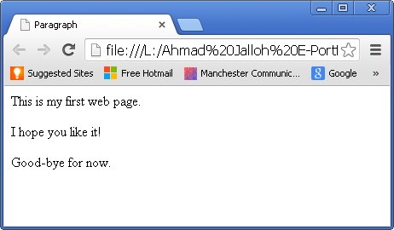

Exercise 5: Text Alignment

As well as providing line breaks the <P> tag can be used to set the alignment of text in a paragraph. Try the following changes to your HTML file:

<HTML>
<HEAD>
<TITLE>Paragraph and Alignment</TITLE>
</HEAD>

</BODY>
<P ALIGN=CENTER>
This is my first web page.
</P>
<P ALIGN=LEFT>
I hope you like it!
</P>
<P ALIGN=RIGHT>
Good-bye for now.
</P>
</BODY>
</HTML>

Save the notepad as “Paragraph.htm”.
Open the file on web browser and your page should display something that looks similar to the page below 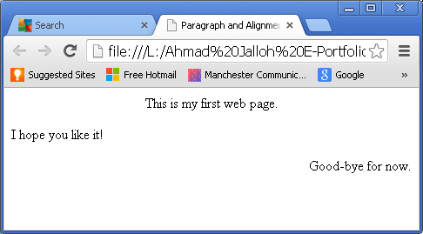

Exercise 6: The Line Break Tag

The <BR> tag works differently. The <P> tag adds a blank line into your text, the <BR> tag simply starts the text on a new line without a gap. Also the <BR> tag is not used in pairs (i.e. there is no </BR> tag). Try the example below:

<HTML>

<HEAD>
<TITLE>Line Break</TITLE>
</HEAD>

<BODY>
<P ALIGN=CENTER>
This is my second web page.
</P>
<P ALIGN=LEFT>
I hope you like it!
</P>
<P ALIGN=RIGHT>
Good-bye for now. <BR> See you again soon
</P>
</BODY>

</HTML>

Save the notepad as “Line Break.htm”.
Open the file on web browser and your page should display something that looks similar to the page below

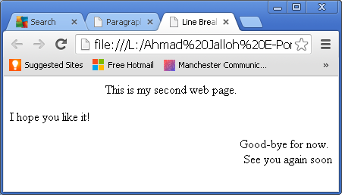

Exercise 5: Heading Format
Open a new notepad and type in the following documents

<HTML>

<HEAD>
<TITLE>Heading Format</TITLE>
</HEAD>

<BODY>
<h1>This is heading 1 and its the biggest</h1>
<h2>This is a heading 2 and it is less bigger than heading 1</h2>
<h3>This is a heading 3 and it is less bigger than heading 2</h3>

</BODY>

</HTML>

Save the notepad as “Heading Format”.
Open the file on web browser and your page should display something that looks similar to the page below.
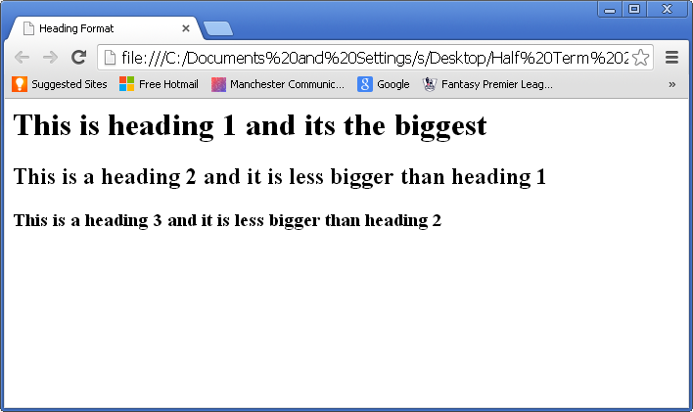

Exercise 6: Text Format
Open a new notepad and type in the following documents

<HTML>
<HEAD>
<title>Text Format</title>
</HEAD>
<BODY>

<H1>Different Text Format</H1>
<P><B>This text is in bold</B></P>

<P><U>This text is underline</U></P>

<I>This text is in italic</I><BR>

<STRICK>This text is stricke</STRICK><BR>

<CEBTER> This text is centered</CENTER><BR>

<B>This is bold and </B><I>italic</I><BR>
</BODY>
</HTML>

Save the notepad as “Text Format”.
Open the file on web browser and your page should display something that looks similar to the page below.

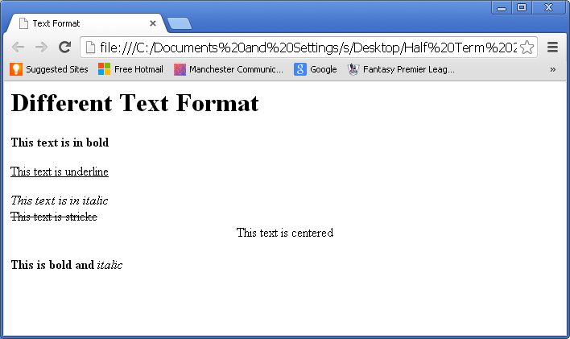

Exercise 7: Colours

The first thing you can do to improve the look of the page is to alter the colour of the background of the page and the colour of the text on the page. This can be done using the <BODY> tag. For example you can alter the look of the page you have created by changing the <BODY> tag as shown below (altered line shown in bold):

Open a new notepad and type in the following;

<HTML>
<HEAD>
<TITLE>Colour</TITLE>
</HEAD>
<BODY TEXT="white" BGCOLOR=“blue”>
<H1>Colours</H1>
<P>The background colour of this page is blue. </P>
<P>The text colour on this page is white. </P>
</BODY>
</HTML>

Save the notepad as “Colour”.
Open the file on web browser and your page should display something that looks similar to the page below.

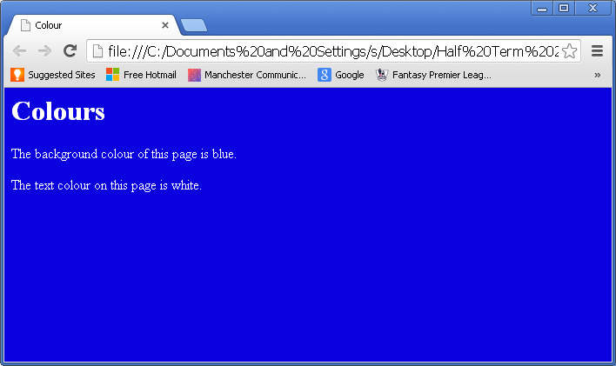

Note that BGCOLOR sets the background colour. You can set only a small number of colours this way (BLACK, RED, GREEN, for example). For a wider range of colours you need to use numeric colour codes, which is explained later.

Exercise 8: Challenge

Create a web page that looks like the one below;
MY WEB SITE

Welcome to my new web site

You can find out about me, my hobbies and my pets here.

My name is
I am years old

You can contact me at:

E-mail: myname@notmail.com
Or you can phone me on

I am studying at Copley Academy

Come back soon and check the latest additions to this site

The title of the page should be “yourname’s web site”, the background should be green and the text should be white. Save it on your “My Website” folder as “MyPage.htm” (you will need it for the next exercise).

Lesson 2

Exercise 1: Image
In this exercise, you will learn how to insert image on a web page using HTML tags
First of all you need to create and Image folder
Find the images you need to use and save them in the image folder

Open a new notepad and type in the following text.

<HTML>

<HEAD>
<TITLE>Image</TITLE>
</head>

<BODY>
<H1> Sorry the dog ate my webpage</H1>

<CENTER>
<IMG SRC="Images\dog-homework.gif">
</CENTRE>

</BODY>

</HTML>

Save the notepad as “Image.htm”

Note:
It is important to save the images in a folder within the same location as the web pages.

Open the file on web browser and your page should display something that looks similar to the page below.
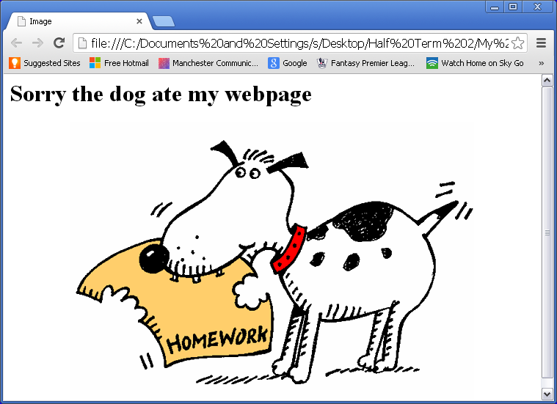

Exercise 2: Hyperlinks
Open a new notepad and type in the following text.

<HTML>

<HEAD>
<TITLE>Link Page</TITLE>
</HEAD>

<BODY>
<H1> This is a Link Page</H1>

<CENTER>
<IMG SRC="Images\Homework.jpg">
</CENTER>

<A HREF=image.htm>View Image page </A>

</BODY>

</HTML>

Save the notepad as “Link.htm” and open the file on web browser. It should look like the page below;

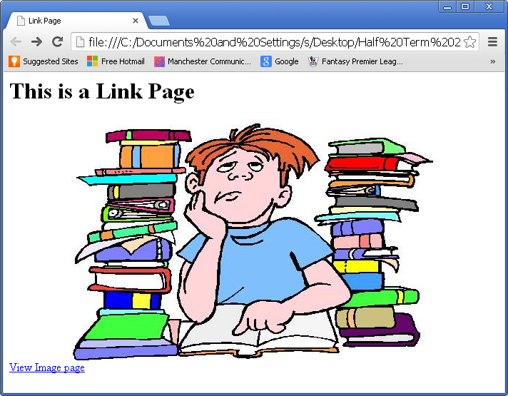
Notice the hyperlink you created

Exercise 3: Hyperlinks

Re-open Images page in notepad and create a hyperlink to Link page and name it “View Link Page” and test that both links work
Exercise 4: Hyperlinks cont...
Re-open Exercise 4 in notepad and create a hyperlink to Exercise 5 and test that the link work

Exercise 5: Challenge
Create a web page that looks like the one below and link it to the “MyPage.htm” you created in your previous lesson.

MY Hobbies

Welcome to my hobbies page

My favourite hobbies are as follows;

I like playing computer games



I also like playing football:

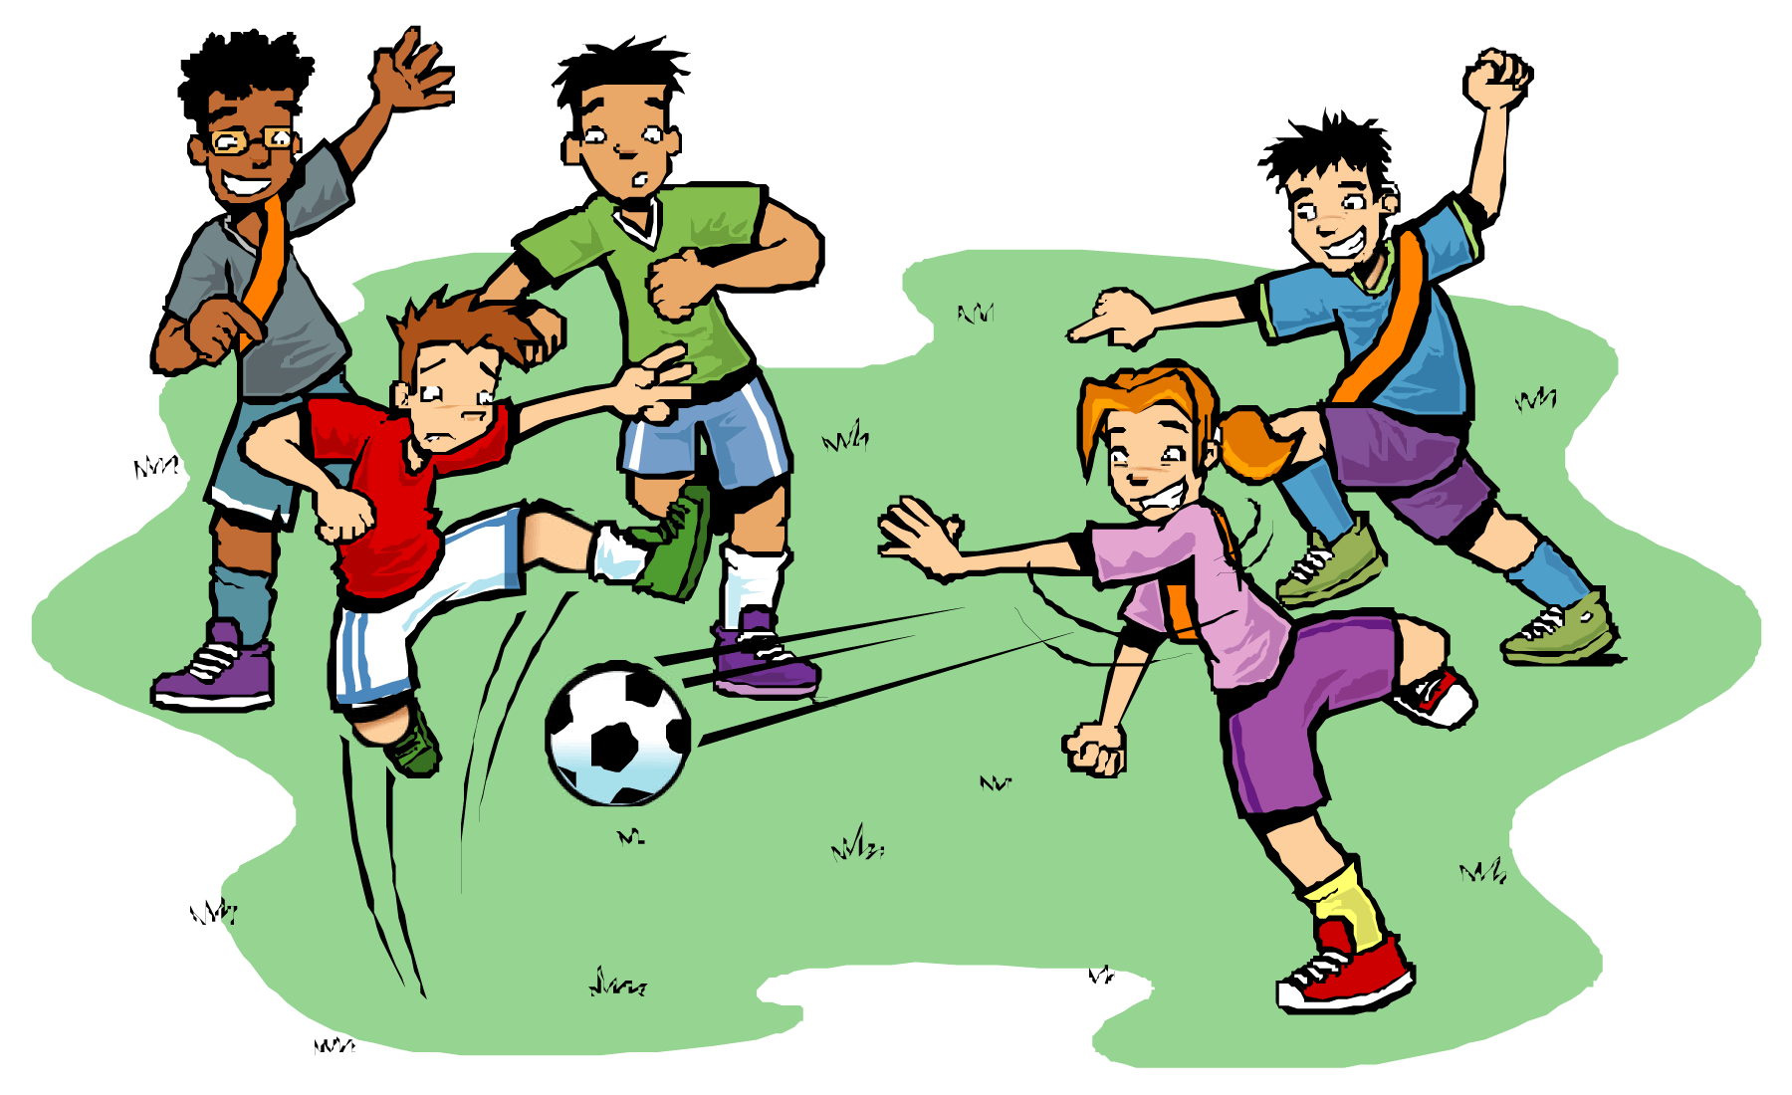

Come back soon and check the latest additions to this site

The title of the page should be “My Hobbies”. You must choose a suitable background and text colours. Save it on your “My Website” folder as Hobbies.htm (you will need it for the next lesson).

Lesson 3:

Exercise 1: Lists

You can display bulleted or numbered lists. For bulleted lists the <UL> tag starts the list and </UL> ends it, individual items start with the <LI> tag. For example:

Open a new notepad and type in the following

<html>
<head>

<title> Paragraph and Break</title>
</head>

We have the following pets in our house:
<UL>
<LI>A dog called shep
<LI>A terrapin called Terry
<LI>A rabbit called Pudding
<UL>

</body>
</html>

Save the notepad as “List.htm”.
Open the file on web browser and your page should display something that looks similar to the page below

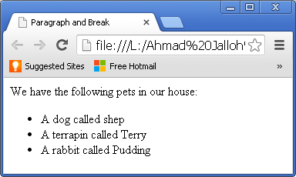

Numbered lists work the same way but instead of the <UL> and </UL> tags the <OL> and </OL> tags are used.

Challenge: Recreate the list above with numbers format instead of bullet points
Exercise 2: Tables
Let's begin with a simple and common use for tables: an office phone list. Suppose we have four people whose names we want on the list. The data could be arranged in a table like this:

<HTML>

<HEAD>
<TITLE>Table</TITLE>
</HEAD>

<BODY>

<TABLE>
<TR> <TD>Raha Mutisya</TD> <TD>1493</TD> </TR>
<TR> <TD>Shalom Buraka</TD> <TD>3829</TD> </TR>
<TR> <TD>Hallie Curry</TD> <TD>8372</TD> </TR>
<TR> <TD>Shari Smiths</TD> <TD>4827</TD> </TR>
</TABLE>

</BODY>

</HTML>

Save the notepad as “Table.htm”.
Open the file on web browser. This would give you the table below:

Raha Mutisya | 1493
Shalom Buraka | 3829
Hallie Curry | 8372
Shari Smiths | 4827

Important Note

This table uses the basic three tags all tables must have:

<TABLE ...>
This creates the table. Most of the overall properties of the table are defined here, such as if it has borders and what is the table's background colour.

<TR ...> (Table Row)
This defines each row of the table.

<TD ...> (Table Data)
This defines each cell of the table.

Exercise 3: Table Border

The first modification you will make to the above table is to add borders. Borders will help you see how the table is laid out. It is a good idea when designing a table to add borders during the time you design the table, even if you remove them before making the table public.

Open a new notepad and type in the following texts

<HTML>

<HEAD>
<TITLE>Table</TITLE>
</HEAD>

<BODY>

<TABLE BORDER=2>
<TR> <TD>Raha Mutisya</TD> <TD>1493</TD> </TR>
<TR> <TD>Shalom Buraka</TD> <TD>3829</TD> </TR>
<TR> <TD>Hallie Curry</TD> <TD>8372</TD> </TR>
<TR> <TD>Shari Smiths</TD> <TD>4827</TD> </TR>
</TABLE>

</BODY>

</HTML>

Save the notepad as “Table.htm”
Open the file on Internet Browser and the following table would appear on your browser

Raha Mutisya | 1493
Shalom Buraka | 3829
Hallie Curry | 8372
Shari Smiths | 4827

Exercise 4: Challenge
Create a web page that looks like the one below and link it to the “MyPage.htm” and “Hobbies.htm” you created in your previous lessons.

My Pets
We have the following pet in our house;
- A dog
- A cat
- Rabbit

Out pet names their picture are as follow;
Pet | Name and Photo
Dog | Chico  
Rabbit | Pudding  
Cat | Shep  

The title of the page should be “My Pets”. You must choose a suitable background and text colours. Save it on your “My Website” folder as My Pet.htm

