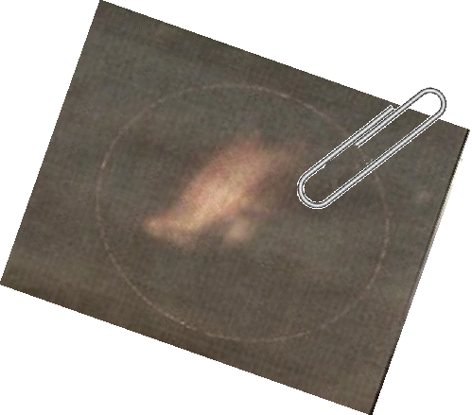
HANDOUT THREE
MYTHBUSTERS CONFIDENTIAL REPORT
Mystery Over New Nessie Sighting
A couple enjoying a romantic weekend in the Highlands believe they may have had a close encounter with the Loch Ness Monster. Experts are now investigating this latest photograph, which was taken by accident, to establish if it is in fact the Loch's most famous resident.

Ian Monckton, from Solihull, took his fiancée Tracey Gordon to a cottage in Invermoriston near the loch, to celebrate her 30th birthday. On their way back to the village at around 11pm they pulled into a lay-by. The driver’s window was wound down and before the couple stopped their car they heard a commotion in the water. Using the car headlights and the flash from his camera to check their footing on the rocky shores of the loch, Ian unwittingly recorded the above picture which he hopes could be the elusive monster.

"There is clearly a very large shape in the water that looks aquatic a few metres out from where I was standing and you just see the tips of the trees lower down the slope to the loch in the photo," said Ian. "I and Tracey were always quite sceptical about Nessie but after having this experience I would say we now have a very open mind on the matter. “It was the highlight of our trip. We'll definitely be back and we are struggling to get an explanation for what we caught on camera." Ian said the picture was taken from a small cliff overlooking the loch. But it was only when they got back to their country retreat and checked the images they realised the significance of what they had on their digital camera. Ian said it was his first visit to Loch Ness and the weather was reasonably clear with only a light breeze. "We decided to get away for a few days to celebrate Tracey's birthday and because it was off season we headed up to Drumnadrochit for a meal. "On our way back we stopped off at Urquhart Castle to take a few photos, but the lights that illuminate the castle were turned off, so there were no photo opportunities there. "Then we pulled over at a parking point to let a car pass, as my fiancé doesn't drive as fast as the locals in the dark. "I had the passenger window open as I was smoking at the time and as we pulled into the lay-by there was a rustling and a splash. It sounded as if a Mini had landed in the water. That's how loud it was. "We both looked at each other and I said "What the hell was that"? It wasn't a small splash like a piece of debris or a stone falling into the loch. It sounded like a car or a motorbike had rolled into the loch. "I got out of the car and walked to the edge using the light from the car headlights to see where the edge of the loch dropped away and taking snaps with the camera so the flash let me see where to tread." The couple called out to see if anyone was there, or in trouble in the loch but couldn't hear anything apart from the water splashing around the loch. "
After a while we continued back to Homewood, both wondering what the hell we had heard and joking about Nessie," Ian added." However, when we looked back at the photos I had taken up to be genuinely believe there is something in this, there is clearly a very large shape in the water that looks aquatic a few metres out from where I was standing and you just see the slope of the loch in the photo."
Original source: http://www.nessie.co.uk

